Maddening moment in immigration debate


By David Crowe
The agonising over population growth has reached another maddening moment where complaints abound and solutions are hard to find.
Australian politicians are right to raise the challenge of rapid migration and the congestion in the big cities, given the way they preside over relentless growth that keeps outstripping their own projections.
Yet their endless talk highlights their impotence. This week saw the rhetoric go into another circuit of a political Bathurst 1000, with the same manoeuvres around Hell Corner and every other twist and turn on Mount Panorama. This is a debate where nothing changes – not even the cars.

Craig Lowndes races in the Bathurst 1000 on Sunday.Credit:AAP
The Morrison government has signalled for the 10th time – Labor is keeping count – that it wants to encourage more migration to the regions in order to ease pressure on the big cities.
Advertisement
Who would argue with this goal? The population of Melbourne grew by 125,000 in the year to June 2017, with net migration making up 80,000 of the total. Greater Sydney grew by 102,000 in the same period with net migration of 85,000, according to the Australian Bureau of Statistics.
No wonder NSW Premier Gladys Berejiklian says her state needs a “breather” from this rapid growth. The congestion is apparent in the nation’s big cities and Australians see no evidence of the reduction in numbers often talked about in Canberra.
This is because the cut to migration highlighted so often by the federal government is not about the net overseas migration that puts more people on buses, trams and trains. And the difference is crucial.

Peter Dutton reduced the permanent migration intake from 183,608 last year to 162,417.Credit:Alex Ellinghausen
Home Affairs Minister Peter Dutton reduced the permanent migration intake from 183,608 last year to 162,417 in the year to June 30, trimming both skilled and family visas. This is the number of people who became permanent residents, not the total that came to visit and stay.
Some Fairfax Media readers know how this cut has been achieved. They have written in to tell us they are waiting longer to get permanent residency for a spouse they married overseas, for instance. The queue for family visas runs to tens of thousands of applications.
Many of those who get permanent residency are already in the country when they apply. The fall in the permanent intake does not mean there were fewer feet on the street.
The real argument is about those who come in for a period of time. Net overseas migration includes any visitors who stay for 12 months or more during a period of 16 months. That is where the cities are experiencing huge growth.

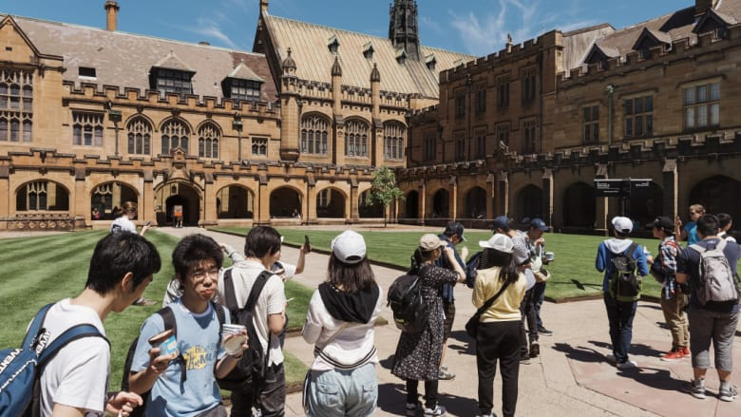

Foreign students are still flocking to Australia's universities. Credit:James Brickwood
The number of overseas students in Australia reached 513,000 late last year, up from 342,000 five years earlier, according to an analysis by the Parliamentary Library. The number of temporary visitors on working holidays was 137,000, down from 146,000 five years earlier.
Berejiklian has a goal that sounds reasonable: return the growth in Sydney to the levels seen during the Howard government. This would mean a 50 per cent cut in net overseas migration. That fact alone shows just how much the numbers have swollen over the past decade.

Related Article



State Parliament

Why the Opera House backlash was so fierce: we've just had enough
Add to shortlist
This is another reminder of that political impotence. The intake has kept growing regardless of all the assurances from the nation’s leaders. The last decade has seen Kevin Rudd welcome a “big Australia” and Julia Gillard reject it, while Tony Abbott vowed to cut the intake.
“I am all in favour of Australia selling education but what I don’t want us to be doing is selling immigration outcomes in the guise of selling education,” Abbott said in July 2010, about five weeks before the election that year.
This is not so different to the warning from Labor employment spokesman Brendan O’Connor in July this year, when he expressed doubts about the uncapped student visa scheme.
“One of the problems we’ve had is we’ve had people coming to Australia, signing up to Mickey Mouse courses,” he said.
The hard part is doing something about it. The numbers have grown regardless of the unease about the program.

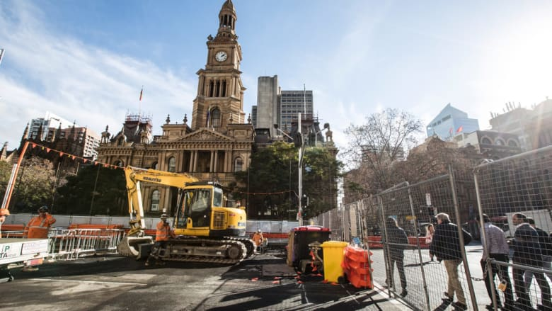

Light rail construction outside Sydney Town Hall in June.Credit:Jessica Hromas
To put a cap on these students is to halt the growth in revenue at the nation’s universities. Catriona Jackson, the chief executive of Universities Australia, says international education brings in about $11.2 billion to the NSW economy each year. She adds that 86 per cent of international students go home after their courses.
This is just one example of the way the challenge is easy to complain about and hard to fix. Why cut the number at all? The problem may be the inability to build the transport and housing to cope with the influx – witness the long wait in Sydney for the light rail that is meant to run along Anzac Parade to the University of NSW.
In a valuable analysis published by Inside Story last month, former Immigration Department deputy secretary Abul Rizvi mentions two ways to slow the growth in overseas students in the big cities: reduce the points for students who graduate from Australian city universities and apply for permanent visas; and apply stricter English tests for those who go to capital cities rather than regional universities.
Rizvi makes a broader point, however, by questioning whether the government should attempt this when it has not worked out a longer-term plan in an age when people are drawn to the big cities. After all, that is where the jobs are.

The dumping of Malcolm Turnbull keeps tempting Scott Morrison and his ministers to talk as if they are a 'new' government.Credit:AAP
Federal cabinet will consider a whole-of-government population policy, including visa changes, in the weeks ahead. The repeated declaration about sending migrants to the regions highlights the severe shortage of big, practical ideas from the government so far.
The awkward fact is that the number of regional sponsored migration scheme visas fell from 20,000 in the year to June 2013 to 10,200 in the last financial year under Coalition rule. Why should voters believe the Coalition can turn that around now?
The new population and migration policy could be a hugely impressive plan, but history tells voters not to put too much faith in the political declarations about migration.
The dumping of Malcolm Turnbull keeps tempting Scott Morrison and his ministers to talk as if they are a “new” government – as if every idea can be treated in isolation without a reminder of their collective record over the past five years.
On religious freedom, the government faces a renewed social dispute it tried to settle with the same-sex marriage plebiscite a year ago. On energy, the government declares the National Energy Guarantee dead but then starts a painful debate over how to fill its own policy vacuum. There are more than a few policies where ministers keep driving around Mount Panorama.
If things need fixing now, who can they blame but themselves? They weren’t elected yesterday.
Voters weren’t born yesterday, either.
David Crowe is chief political correspondent.
https://www.smh.com.au/politics/federal/maddening-moment-in-immigration-debate-20181011-p5092o.html

